IBM Applied Data Science Capstone

The Battle of Neighborhoods

**Henry Hong**

**July 28, 2019**

## 1.0 Introduction Section

**Business Problem:**

My client has been renting an apartment at west San Jose (zip code is 95129) area more than ten years. The leasing rate of a two beds room apartment has been raising dramatically since the crashing of economic bubble in 2008. He pays around 4,500 for his small town-house now rather than 2,200 per month ten years ago. My client is pushing me lately to do a search for buying a house at Silicon Valley if the environment is good and the price is within his budget. I am very excited and want to use this opportunity to practice what I've learned so far from this course. My client's key question is “How can I help him to find a convenient and enjoyable place similar to his current resident area?” I am planning to use the **FourSquare API** that we learned at this course and some real estate API (such as **ZillowAPI**) and **Silicon Valley Real Estate websites** in the market. The idea is to use this chance to apply the knowledge and tools I have learned so far. Here below is the requirement from my client:

* The amenities in the selected neighborhood shall be similar to client's current residence apartment
* The price is under 1.5M
* House must be at least 3 bedrooms, 2 bathrooms, 1 car garage, around 1800 to 2100 square footage of size
* Near the park (within 0.5 mile)
* Near the library (within 1 mile)
* Near the school (within 0.5 mile)
* The schools in the area should have high rating (Ranking greater than 7)
* Not too close to the railroad (at least 3 miles away)
* The location is near the supermarket (within 0.5 miles radius)
* The location is near the shopping mall (within 3 miles radius)
* The location is close (within 1 mile) to venues such as restaurants (Asian and Mexican foods ...etc.), parks and coffee shops
* The neighborhood/community should be safe and have low crime rate

Base on the requirements listed above, I finalize the business problem as:

**How to buy a dream house in Silicon Valley which complies with the requirements of price, features, safety, location and venues?**

**The audience who would be interested in this project:**

This case is also applicable for anyone interested in exploring the ways of searching and analysis the location and real estate data for finding a suitable house to buy in Silicon Valley.

## 2.0 Data Section

**The following data is required to answer the questions of the business problem:**

* List of **public schools** in Santa Clara county with their location data [<https://data.sccgov.org/Education/SchoolsPublic/q83h-ht3q>]
* List of **parks** in Santa Clara county with their location data [<https://data.sccgov.org/Environment/ParkPoints/3t3k-gian>]
* List of **railroad station** in Santa Clara county with their location data [<https://data.sccgov.org/Transportation/RailroadStations/9wv8-3ekq>]
* List of **public library** in Santa Clara county with their location data [<https://data.sccgov.org/Government/Libraries/xxrb-pj5j>]
* List of **crime report** in Santa Clara county with their location data [<https://data.sccgov.org/Public-Safety/Crime-Reports/n9u6-aijz/data>]
* California Santa Clara county **school rating** data [<https://school-ratings.com/counties/Santa_Clara.html>]
* **House price trend** data of the cities in Silicon Valley [<https://julianalee.com/trends.htm>]
* List of **Recent Sold House** dataset based on zip code [<https://julianalee.com/zip-code/95124/95124-home-sales.htm>]
* Data from **Zillow API** for comparable house sales analysis [<https://github.com/asclepiusaka/zillowAPI>]
* Most current list of **houses for sale** in each neighborhoods from real estate website with their addresses, price and selling information [<https://julianalee.com/real-estate/property-organizer-view-saved-search/10279348/>]
* Data from **Foursquare API** [<https://developer.foursquare.com/docs>]

**The dataset and features will be used as following:**

1. Use **geopy Nominatim** to find out the latitude and longitude of current resident apartment.
2. Apply **FourSquare** to find 10 venues around current residence in San Jose.
3. Map current residence place with 10 venues.
4. **Schools Dataset**: [features to be extracted: **'ZIP', 'CITY', 'PLACENAME', 'ADDRESS', 'LATITUDE', 'LONGITUDE'**]. **School Rating Dataset** (WebScraping by **BeautifulSoup**): [features to be extracted: **'SCHOOL', 'RANK'**]. Based on my client's house buying criteria, the school ranking (ranking greater than 7) is a major factor of his consideration. Therefore, I download the public-school information dataset from the Santa Clara county open dataset. The goal is to show those schools with their school ranking on the map to help house selection.
5. **Parks dataset**: [features to be extracted: **'PLACENAME', 'LATITUDE', 'LONGITUDE'**]. My client is considering the potential residence community should be close (within 0.5 mile) to parks. So, I download the parks dataset from Santa Clara county's open data repository. The parks will be shown on the map to help house buying decision.
6. **Railroad stations dataset**: [features to be extracted: **'PLACENAME', 'PLACETYPE', 'LATITUDE', 'LONGITUDE'**]. My client raises a concern about the noise of the trains. So, the potential candidates should not be too close (at least 3 miles away) to the railroad stations. The railroad station will be shown on the map to help my client to make buying decision.
7. **Public Libraries dataset**: [features to be extracted: **'ZIP', 'CITY', 'PLACENAME', 'ADDRESS', 'LATITUDE', 'LONGITUDE'**]. My client enjoys going to libraries. The candidates must be convenient to access to the libraries (within 1 mile). The libraries will be shown on the map to help decision making.
8. **Crime Reports dataset**: [features to be extracted: **'city', 'incident_type_primary', 'parent_incident_type', 'latitude', 'longitude'**]. The safety is the most important factor while considering buying a house. My client emphasize that he won't buy a house in an area with higher crime rate even the price is cheaper. The county provides a huge dataset that contains more the one hundred and fifty thousand records. We have to clean up all those data and only keep those which are essential and suitable for visualization.
9. **House price trends data**: WebScraping by **BeautifulSoup** [features to be extracted: **'City', 'Median Price', '2018 Change', '2017 Change', '2016 Change'**]. My client is aiming at an affordable price within 1.5M so a median prices chart including every city/zipcode can provide my client a better direction of home hunting.
10. Process the ZIP code and Cities: Since we can’t obtain the exact boundaries of the city, I will utilize the public-school dataset which contains all the location data for each school. Usually, higher school density can represent the city when using Foursquare library.
11. Explore Cities in Santa Clara County: [features to be extracted: **'Neighborhood', 'Venue Category', 'venue', 'freq'**]. I will use **Foursquare** to explore all cities/zipcodes. The goal is to find a city that has similar context with my client's current city. The context includes foods, restaurant, coffee shops, gymnastics, interesting points ...etc. I would like to provide a visualization map including similar cities/zipcodes grouped together to my client.
12. Analyze Each Neighborhood/city: Group rows by neighborhood and by taking the mean value of the frequency of occurrence of each category. I will consider each neighborhood along with the top 5 most common venues.
13. Clustering Cities/Zipcodes: Use **KMean or DBScan algorithm** for clustering analysis
14. **Recent Sold House Price Data**: WebScraping by **BeautifulSoup** [features to be extracted: **'ZIP', 'ADDRESS', 'ORGLD', 'ORIG LSPRC', 'LIST PRICE', 'SALE PRICE', 'SQFT', 'LOTSZ', 'COE', 'DOM'**]. I will use geopy Nominatim library to get the latitude and longitude values. The goal is to show those houses with features and sold price on the map to help decision making.
15. House **Comparable Sales Analysis**: [features to be extracted: **'zpid', 'zipcode', 'city', 'street', 'year_built', 'lot_size', 'finished_size', 'bedrooms', 'bathrooms', 'zestimate', 'last_sold_price', 'last_sold_date', 'latitude', 'longitude', 'home_details', 'similar_sales'**]. Use **Zillow API** to get house features from Zillow real estate database

**The processing of these DATA will allow to answer following key questions to make the buying decision:**

* Which city/zipcode is good to consider while considering the **price** (less than 1.5M)?
* Which city/zipcode is good to consider while considering the **school** (within 0.5 mile and ranking > 7)?
* Which city/zipcode is good to consider while considering the **park** (within 0.5 mile)?
* Which city/zipcode is good to consider while considering the **library** (within 1 mile)?
* Which city/zipcode is good to consider while considering the **railroad** (at least 3 miles away)?
* Which city/zipcode is good to consider while considering the **supermarket** (0.5 mile radius)?
* Which city/zipcode is good to consider while considering the **shopping mall** (within 3 miles radius)?
* Which city/zipcode is good to consider while considering the **foods, restaurants (Asian and Mexican foods ...etc) and coffee shops**?
* Which city/zipcode is good to consider while considering the **safety** (low crime rate)?
* Which city/zipcode has the **best housing pricing**?
* Are there **tradeoffs** between size, price, location and safety?
* What are the venues of the **two best houses** to buy?
* Any other **interesting statistical data** findings from the **Foursquare** and **ZillowAPI** real estate data?

## 3.0 Methodology Section

### 3.1 San Jose Map - Current residence and venues in San Jose

The geopy Nominatim geocoders is used to locate the location data of current rental apartment

***Apply FourSquare to find venues around current residence in San Jose***

|  |  |  |  |
| --- | --- | --- | --- |
| **name** | **categories** | **lat** | **lng** |
| 85C Bakery Cafe | Bakery | 37.304041 | -122.032565 |
| Go Fish Poke Bar | Sushi Restaurant | 37.304019 | -122.032889 |
| Music Tunnel KTV Cafe | Karaoke Bar | 37.305849 | -122.032095 |
| Happy Feet | Massage Studio | 37.308560 | -122.032756 |
| Hmart (H Mart) | Supermarket | 37.304296 | -122.033366 |

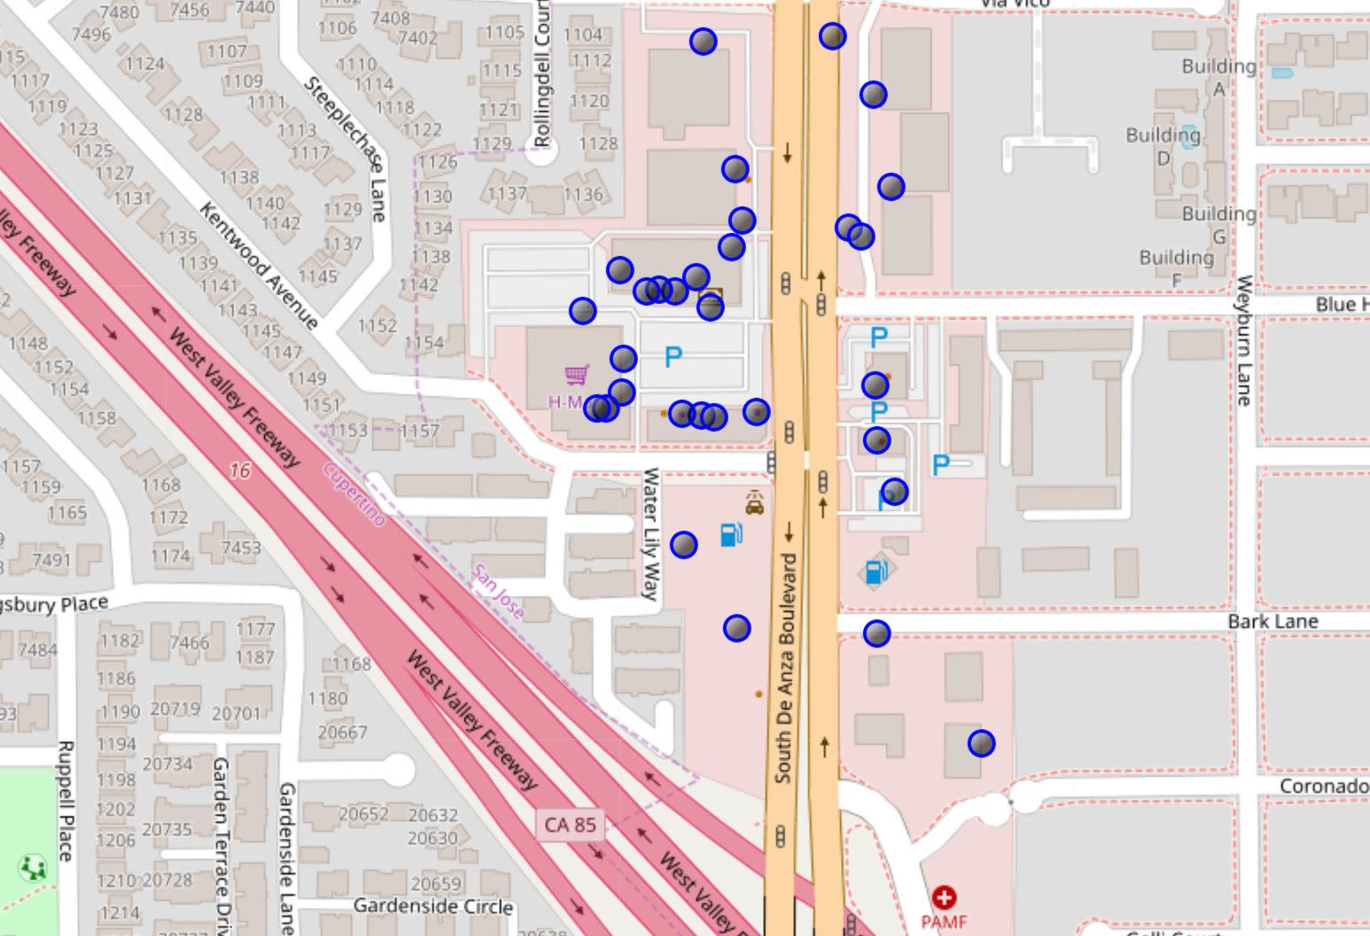

### 3.2 Import Schools Datasets

Based on my client's house buying criteria, the school ranking (ranking greater than 7) is a major factor of his consideration. Therefore, I download the public-school information dataset from the Santa Clara county open dataset. The goal is to show those schools with their school ranking on the map to help house selection.

|  |  |  |  |  |  |  |
| --- | --- | --- | --- | --- | --- | --- |
| **ZIP** | **CITY** | **PLACENAME** | **ADDRESS** | **LATITUDE** | **LONGITUDE** | **RANK** |
| 94022 | Los Altos Hills | Gardner Bullis Elementary | 25890 Fremont Road | 37.380923 | -122.130325 | 10 |
| 94022 | Los Altos | Los Altos High | 201 Almond Avenue | 37.386302 | -122.108160 | 10 |

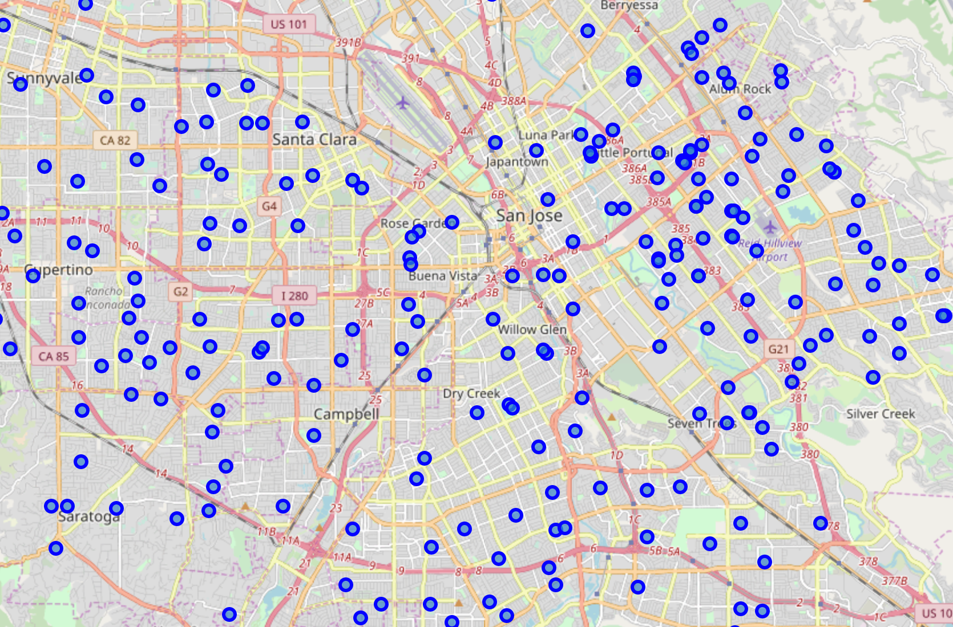

### 3.3 Import Parks dataset

My client is considering the potential residence community should be close (within 0.5 mile) to parks. So, I download the parks dataset from Santa Clara county's open data repository. The parks will be shown on the map to help house buying decision.

|  |  |  |
| --- | --- | --- |
| **PLACENAME** | **LATITUDE** | **LONGITUDE** |
| Cassell Park | 37.345192 | -121.827989 |
| Sinnott Park | 37.420058 | -121.873051 |
| Byxbee Recreation Area | 37.453678 | -122.104850 |

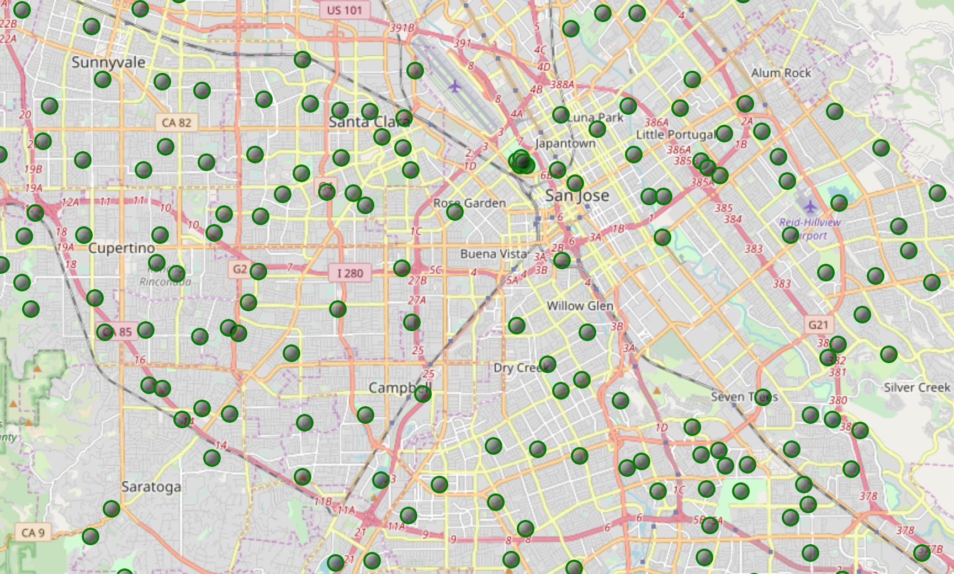

### 3.4 Import Railroad Stations dataset

My client raises a concern about the noise of the trains. So, the potential candidates should not be too close (at least 3 miles away) to the railroad stations. The railroad station will be shown on the map to help my client to make buying decision.

|  |  |  |  |
| --- | --- | --- | --- |
| **PLACENAME** | **PLACETYPE** | **LATITUDE** | **LONGITUDE** |
| Mountain View Station | Railroad Station | 37.394233 | -122.075679 |
| California Ave Station | Railroad Station | 37.429011 | -122.142593 |
| San Jose Diridon Station | Railroad Station | 37.329921 | -121.902476 |

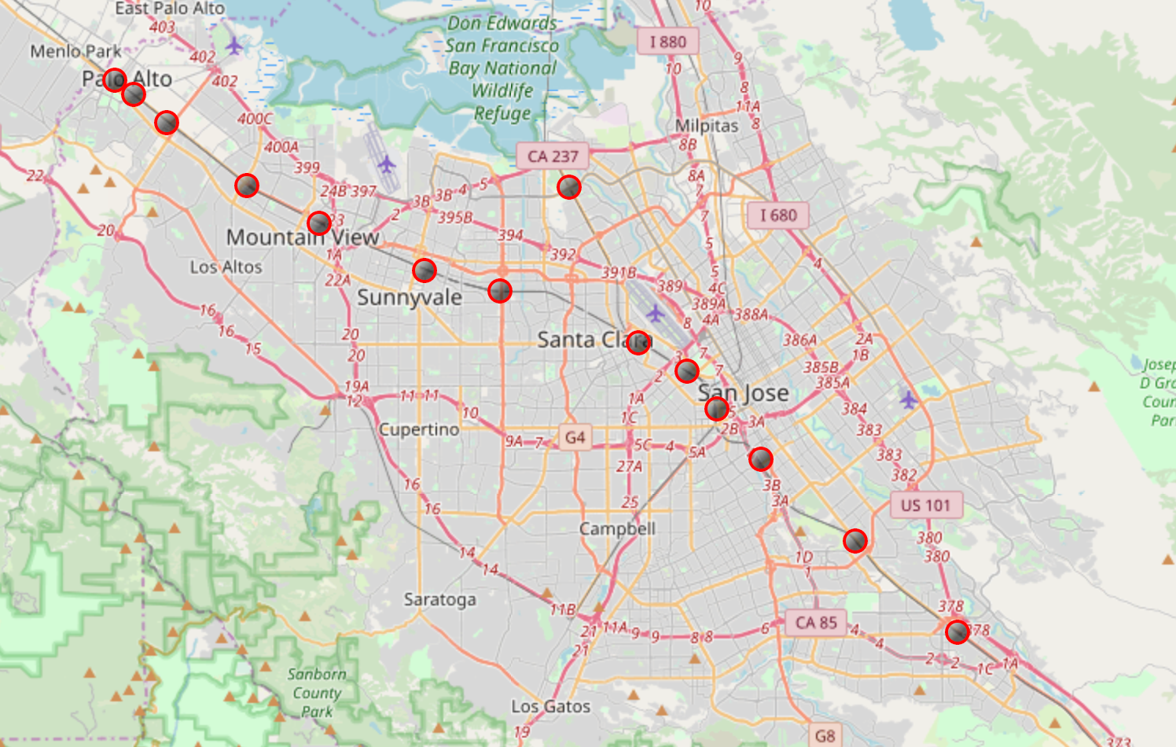

### 3.5 Import Public Libraries dataset

My client enjoys going to libraries. The candidates must be convenient to access to the libraries (within 1 mile). The libraries will be shown on the map to help decision making.

|  |  |  |  |  |  |
| --- | --- | --- | --- | --- | --- |
| **ZIP** | **CITY** | **PLACENAME** | **ADDRESS** | **LATITUDE** | **LONGITUDE** |
| 95112 | San Jose | King Library | 150 E. San Fernando St. | 37.335808 | -121.885956 |
| 95020 | Gilroy | Gilroy Library | 7652 Monterey Street | 37.010609 | -121.570278 |
| 95111 | San Jose | Tully Community Branch Library | 880 Tully Rd. | 37.311890 | -121.840735 |

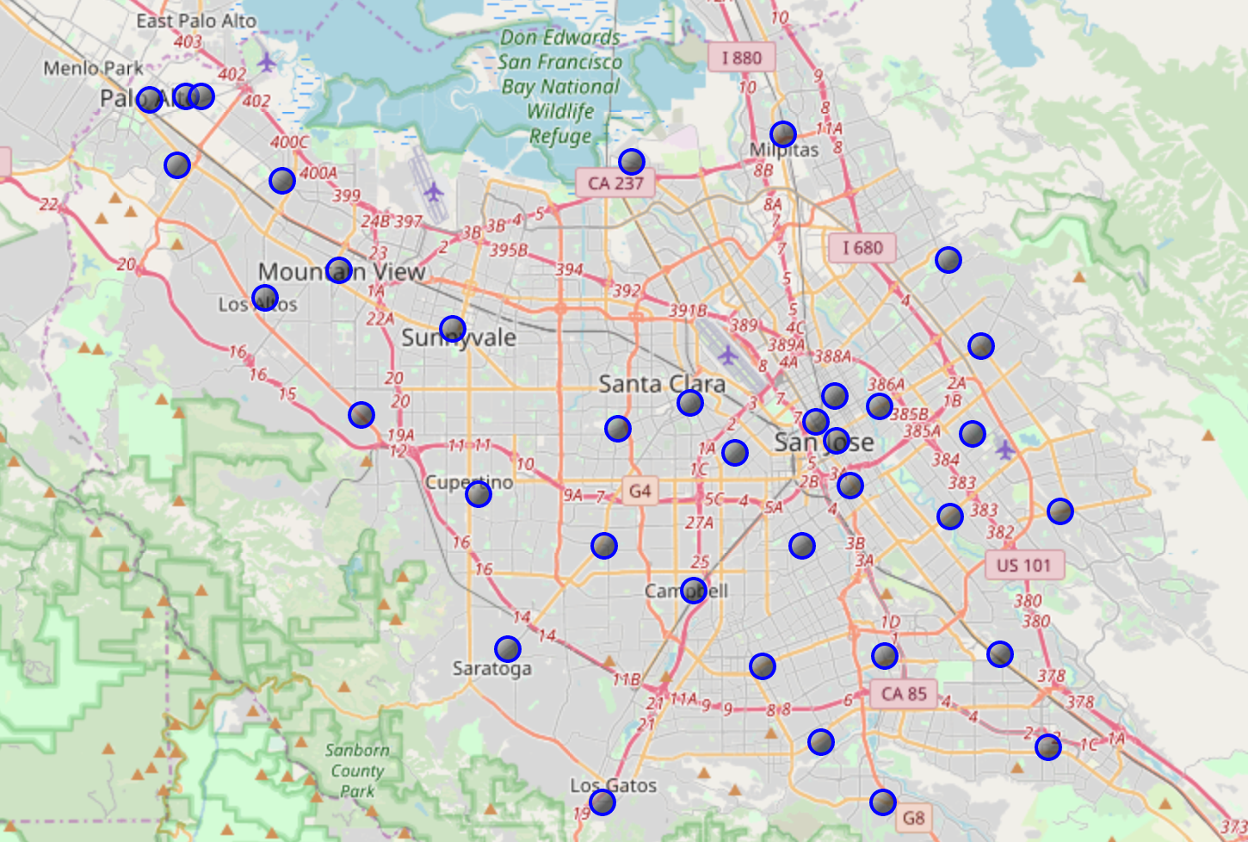

### 3.6 Import Crime Reports dataset

The safety is the most important factor while considering buying a house. My client emphasize that he won't buy a house in an area with higher crime rate even the price is cheaper. The county provides a huge dataset that contains more the one hundred and fifty thousand records. We have to clean up all those data and only keep those which are essential and suitable for visualization.

|  |  |  |  |  |
| --- | --- | --- | --- | --- |
| **city** | **incident_type_primary** | **parent_incident_type** | **latitude** | **longitude** |
| SANTA CLARA COUNTY | Other | Other | 37.227733 | -121.808192 |
| SANTA CLARA COUNTY | MEET THE CITIZEN | Community Policing | 37.377026 | -121.831527 |
| SANTA CLARA COUNTY | T/C, MAJOR INJURIES | Traffic | 37.292336 | -121.996517 |

Most of the crime records are traffic violation and pity things that people won't worry too much. So, we reduce the rows down to around three thousand by screening out the records by the keyword "Theft" and "Vehicle"

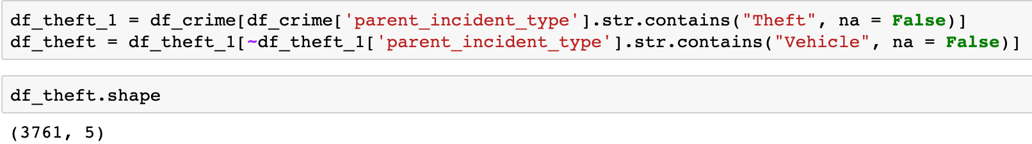

The rows can be further reduced by dropping the duplicated rows with the same value in latitude and longitude columns. This means we only plot once in the same spot where may encounter theft many times.

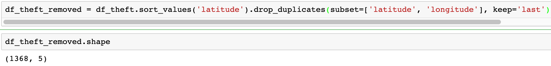

Thirteen hundred is still too many for a clear visualization. So, we randomly sample five hundred rows for the final displaying.



|  |  |  |  |  |
| --- | --- | --- | --- | --- |
| **city** | **incident_type_primary** | **parent_incident_type** | **latitude** | **longitude** |
| SANTA CLARA COUNTY | GRAND THEFT | Theft | 37.086943 | -121.569279 |
| SANTA CLARA COUNTY | PETTY THEFT | Theft | 37.394689 | -122.077510 |
| SANTA CLARA COUNTY | THEFT | Theft | 37.093998 | -121.584397 |

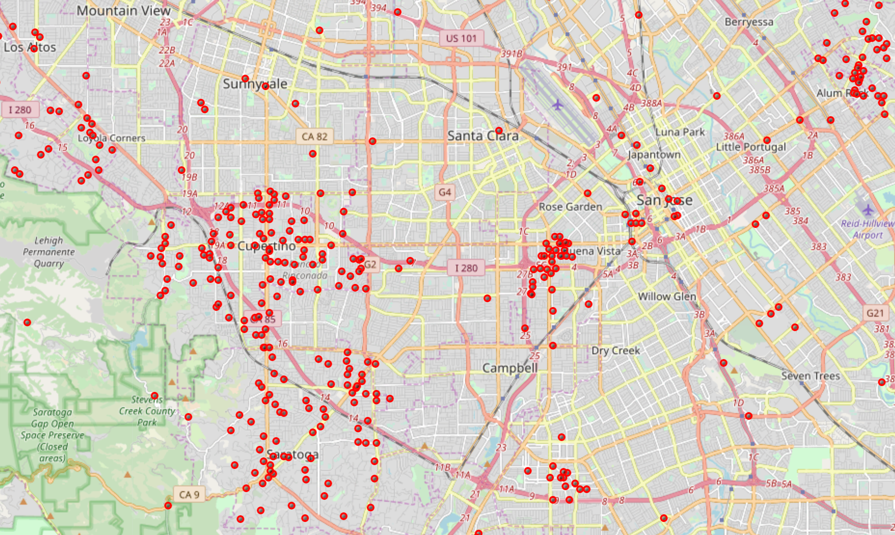

### 3.7 Download the house price trends data

My client is aiming at an affordable price within 1.5M so a median prices chart including every city/zipcode can provide my client a better direction of home hunting. The following real estate site provides a very informative data for the house buyers. We can apply the web scraper technique (BeautifulSoup) that we've learned in the course. However, this site won't allow us to do so since that might affect their performance. This prohibition also exists for some popular real estate information websites such as Zillow and Trulia. I've downloaded the dataset about the market trends this month for the Silicon Valley cities. We can base on it and realize the most recent house price and their price changes. My client is aiming an affordable price within 1.5M so the information should be able to give him the idea that which city or zipcode area he should be looking for.

**Median Prices for Silicon Valley Cities**

|  |  |  |  |  |
| --- | --- | --- | --- | --- |
| **City** | **Median Price** | **2018 Change** | **2017 Change** | **2016 Change** |
| Atherton | US$6,650,000 | 40.00% | -19.80% | 0.40% |
| Belmont | US$1,825,000 | 10.10% | 8.70% | 1.00% |
| Brisbane | US$1,200,000 | 22.40% | 5.40% | 16.00% |

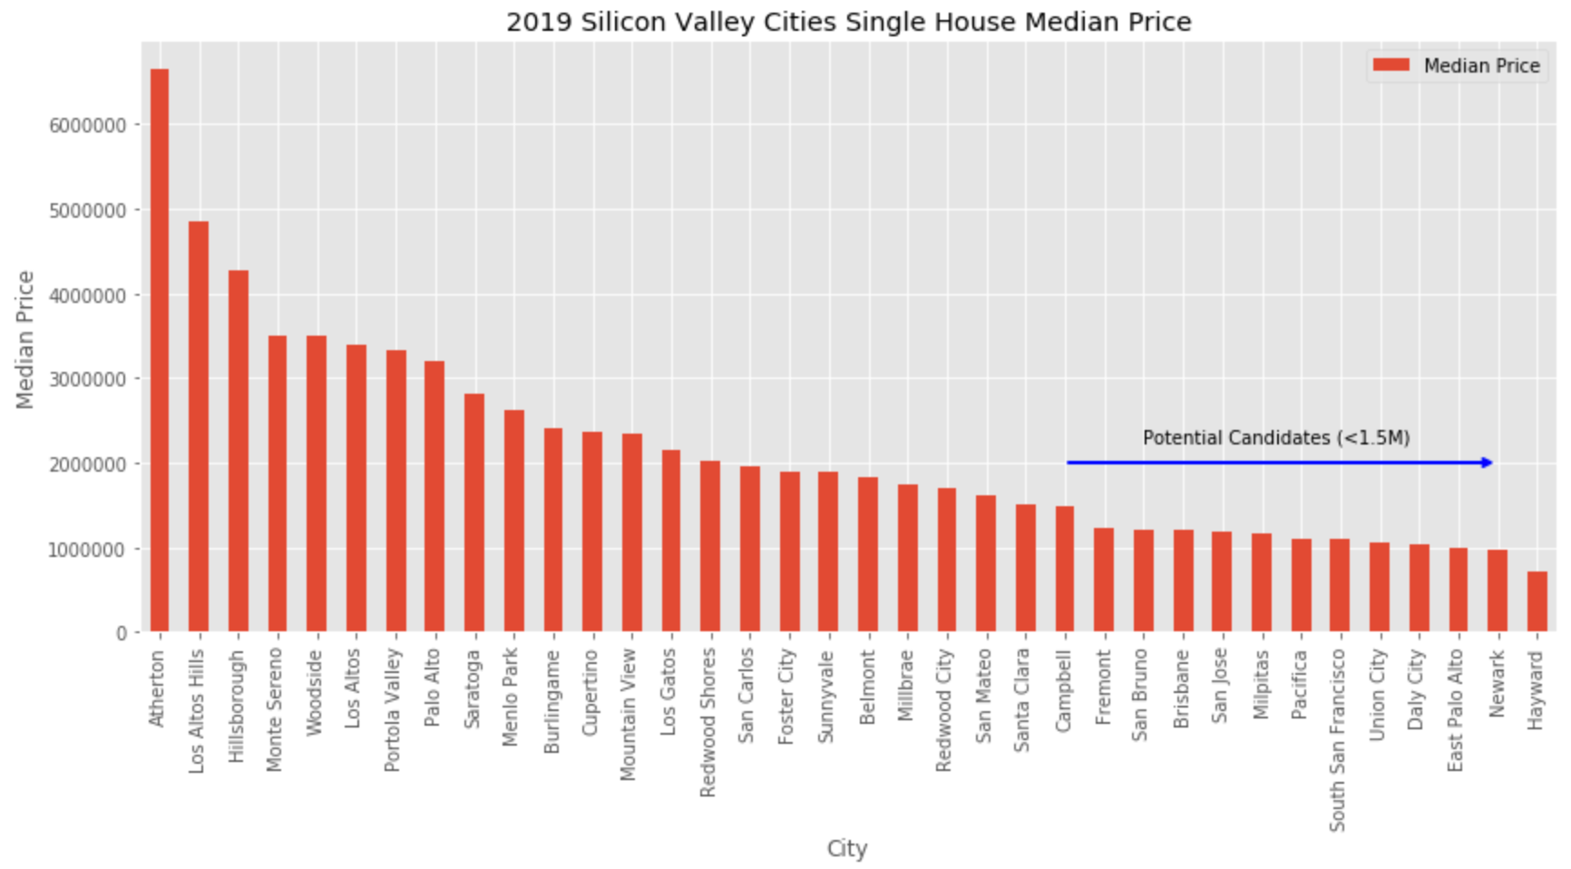

### 3.8 Process the ZIP codes and Cities

Since we can’t obtain the exact boundaries of the city, I will utilize the public-school dataset which contains all the location data for each school. Usually, higher school density can represent the city when using Foursquare library.

A city may contain several zip codes but not vice versa. So, we can group the duplicated rows (zip codes) and calculate the mean latitude and longitude values for each new group (unique zip code)

|  |  |  |  |
| --- | --- | --- | --- |
| **ZIP** | **CITY** | **LATITUDE** | **LONGITUDE** |
| 94022 | Los Altos Hills | 37.388248 | -122.115675 |
| 94024 | Los Altos | 37.363458 | -122.087928 |
| 94040 | Mountain View | 37.374295 | -122.080710 |
| 94041 | Mountain View | 37.388177 | -122.071375 |

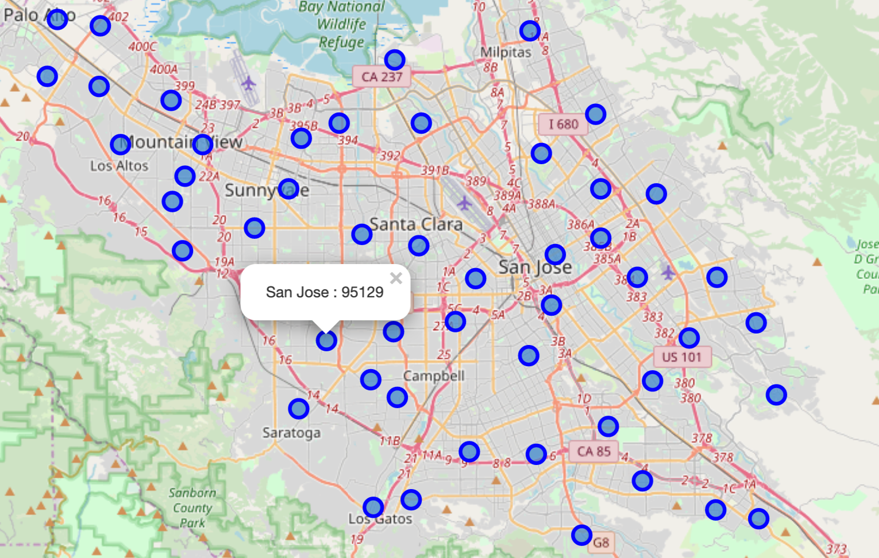

### 3.9 Explore Cities in Santa Clara County

This is the most important part since my client enjoy his current environment and facilities. I will use Foursquare to explore all cities/zipcodes. The goal is to find a city that has similar context with my client's current city. The context includes foods, restaurant, coffee shops, gymnastics, interesting points ...etc. I would like to provide a visualization map including similar cities/zipcodes grouped together to my client.

**Analyze Each Neighborhood**

Group rows by neighborhood and by taking the mean value of the frequency of occurrence of each category. I will consider each neighborhood along with the top 5 most common venues.

**Clustering Cities/Zipcodes**

I use KMean algorithm for the clustering analysis. The kclusters is set to 4. The result is shown as below map.

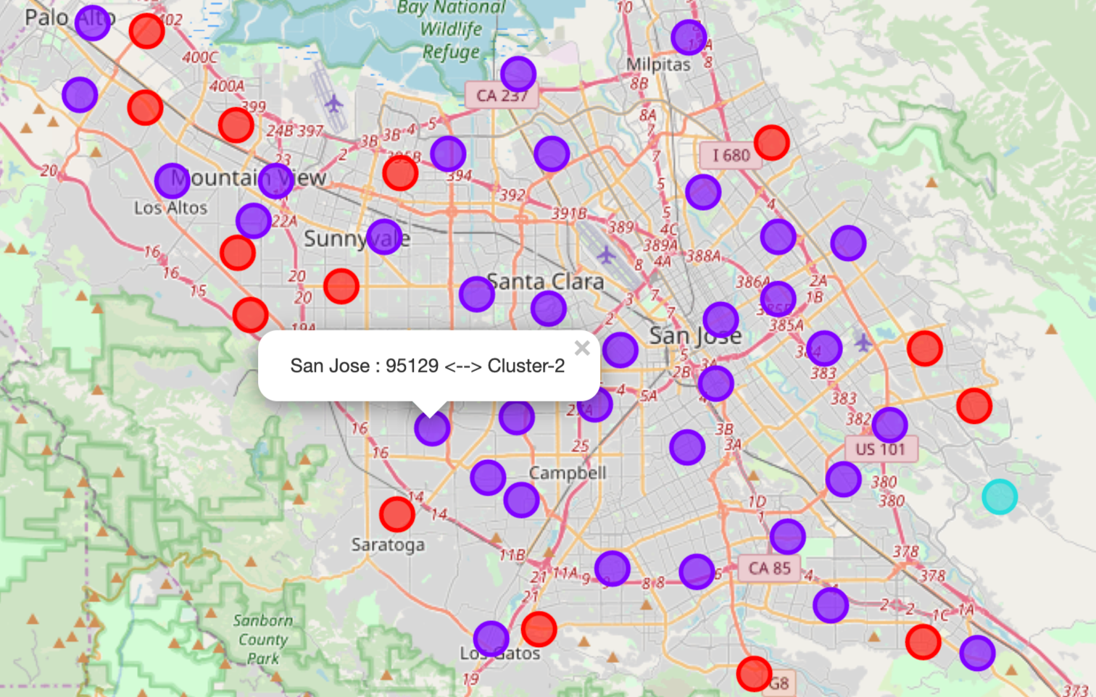

### 3.10 Import Recent Sold House Price Data

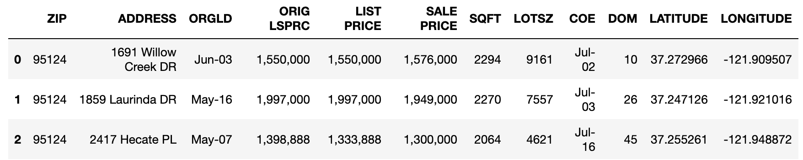

**Use Zillow API to get some house features from Zillow real estate database**

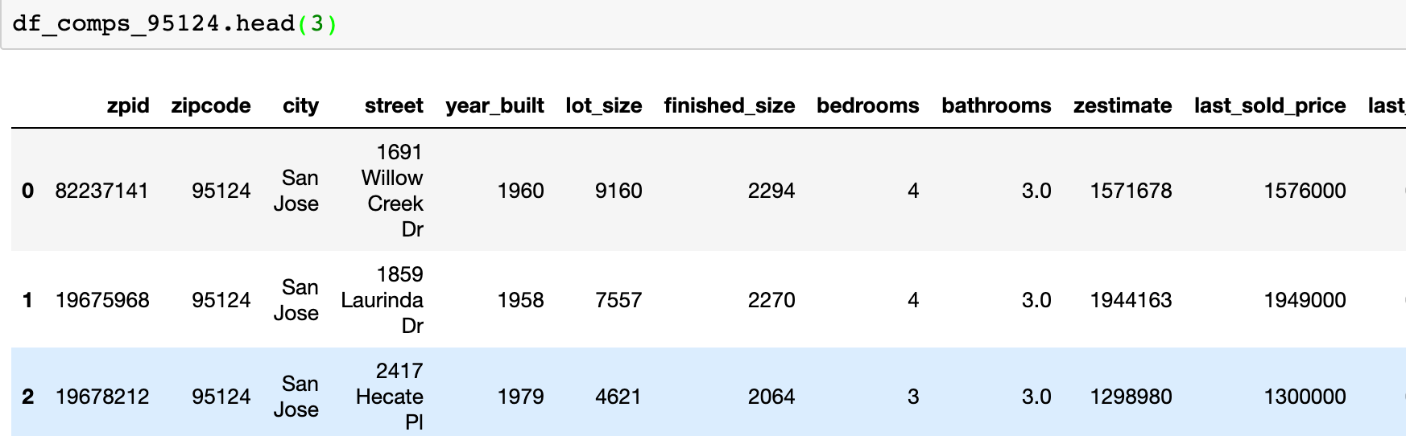

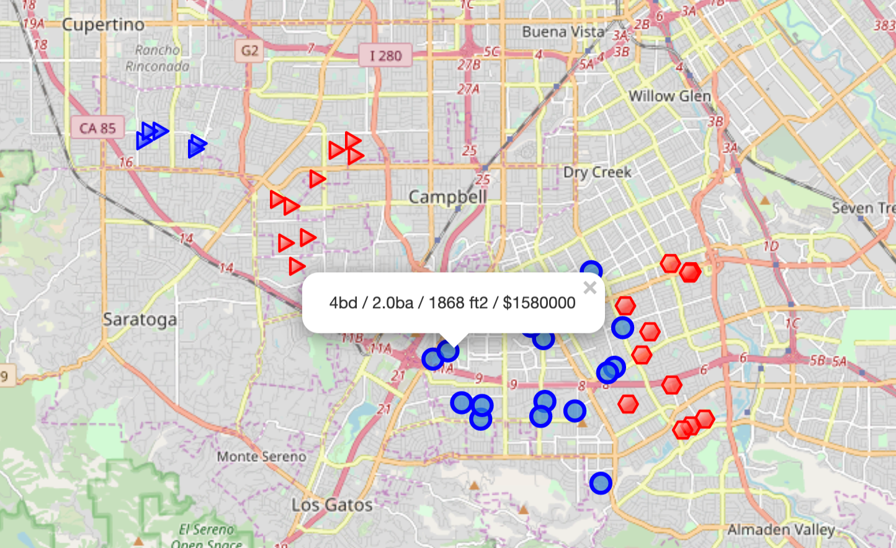

## 4.0 Results Section

**Consolidated Map of Santa Clara county with schools, parks, libraries and cluster of cities**

**1. School --- Red Circle**

**2. Park --- Green Hexagon**

**3. Library --- Blue Square**

**4. Cluster of city --- Large Circle (same cluster = same color)**

**5. Comparable Houses in 95124 --- Blue Triangle**

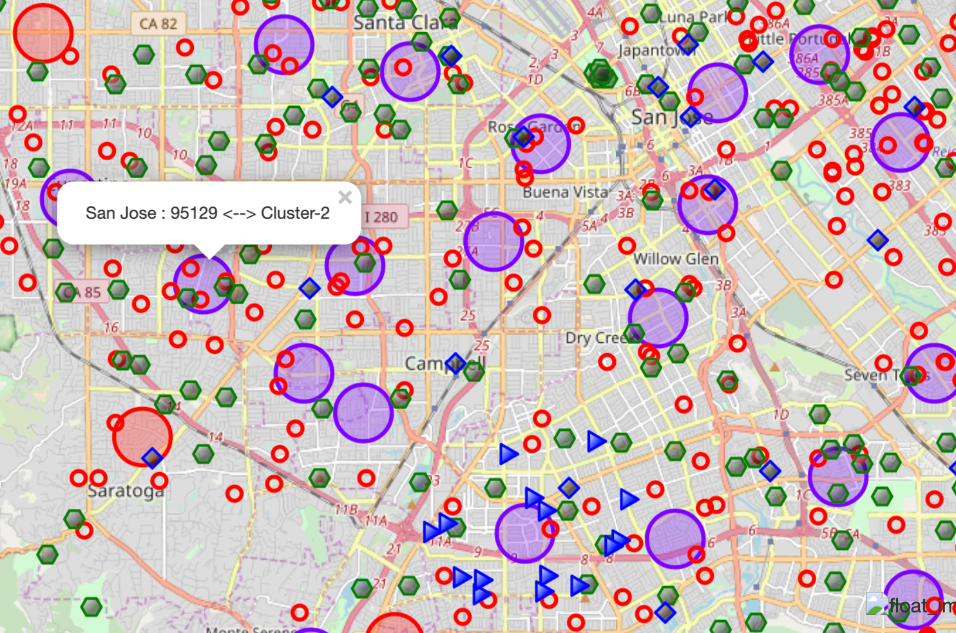

### 4.1 Problem Resolution:

**The amenities in the selected neighborhood shall be similar to his current residence apartment**

**Solution:**

My client lives in 95129 which is cluster-2 (label starts from 0) on the map. Therefore, the candidate cities/zipcodes should come from the same cluster. The number of candidate zipcodes is going down from 53 to 37 (Number will be different based on clustering result).

### 4.2 Problem Resolution:

**The price of house for sales is under 1.5M**

**Solution:**

There are only two cities remained (Campbell and San Jose) if we consider the affordable prices and the location (Gilroy and Morgan Hill are too far away from my client's current resident 95129). The number of candidate zipcodes goes down to 21 (Number will be different based on clustering result)

### 4.3 Problem Resolution:

**Not too close to the railroad (at least 3 miles away)**

**Solution:**

When we consider at least 3 miles away from railroad, the candidate zipcodes will be reduced to 9 (Number will be different based on clustering result). That is a lot easier when making the final decision

### 4.4 Problem Resolution:

**1) Near the school (within 0.5 mile)**

**2) The schools in the area should have high rating (Ranking greater than 7)**

**Solution:**

My client can use the average school rating to select the location of his potential home.

The Average School Rating of 95008: 6.0

The Average School Rating of 95117: 6.0

The Average School Rating of 95118: 7.6

The Average School Rating of 95124: 9.1

The Average School Rating of 95127: 4.1

The Average School Rating of 95129: 9.7

The Average School Rating of 95130: 9.8

The Average School Rating of 95131: 7.0

The Average School Rating of 95133: 5.7

### 4.5 Problem Resolution:

**The neighborhood/community should be safe and have low crime rate**

**Solution:**

We display the crime locations and the final candidate zipcodes on the same map.

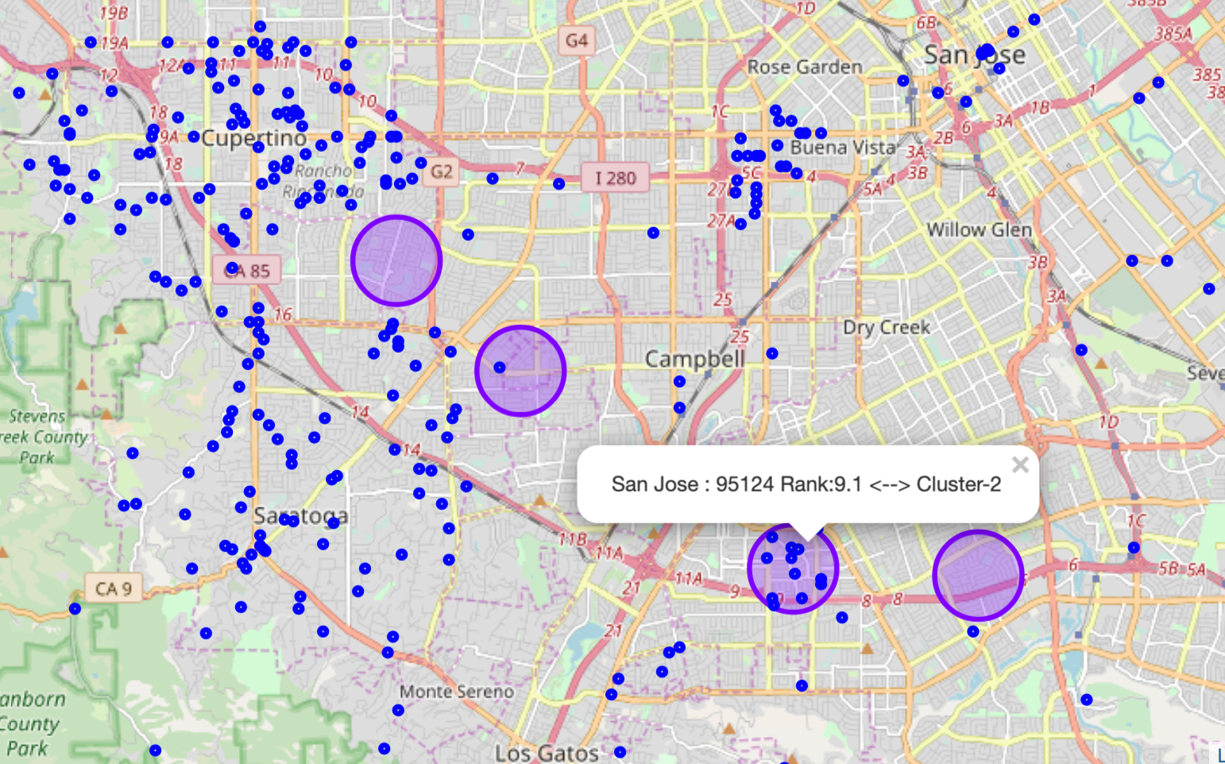

### 4.6 Problem Resolution:

**1) Near the park (within 0.5 mile)**

**2) Near the library (within 1 mile))**

**Solution:**

My client can use the location data (latitude and longitude) of the library when making buying decision. The parks do not have zip code associated with them. However, we can use their latitude and longitude to know the distances from the candidate houses.

There are 1 library in 95118

There are 1 library in 95124

There are 0 library in 95129

There are 0 library in 95130

|  |  |  |
| --- | --- | --- |
| **PLACENAME** | **LATITUDE** | **LONGITUDE** |
| Cassell Park | 37.345192 | -121.827989 |
| Sinnott Park | 37.420058 | -121.873051 |
| Byxbee Recreation Area | 37.453678 | -122.104850 |

### 4.7 Problem Resolution:

**House must be at least 3 bedrooms, 2 bathrooms, 1 car garage, around 1800 to 2100 square footage of size**

**Solution:**

Follow section 3.10 Recent Sold House Price Data, we can obtain the recent sold houses information. This information can then be used when negotiating the deal with the seller.

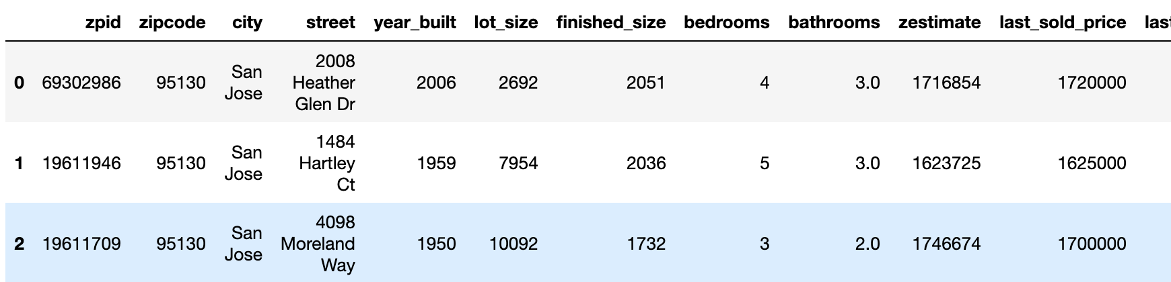

### 4.8 Problem Resolution:

**1) The amenities in the selected neighborhood shall be similar to his current residence apartment**

**2) The location is near the supermarket (within 0.5 mile radius)**

**3) The location is near the shopping mall (within 3 miles radius)**

**4) The location is close (within 1 mile) to venues such as restaurants (Asian and Mexican foods ...etc.), parks and coffee shops ...**

**Solution:**

Refer to section 3.9 Explore Cities in Santa Clara County, we can run the Foursquare on three final dream home candidates (simulated by picking from recent sold houses; one for each zipcode; 95130, 95118, 95124) and current living apartment in 95129. The result will be able to address above requirements.

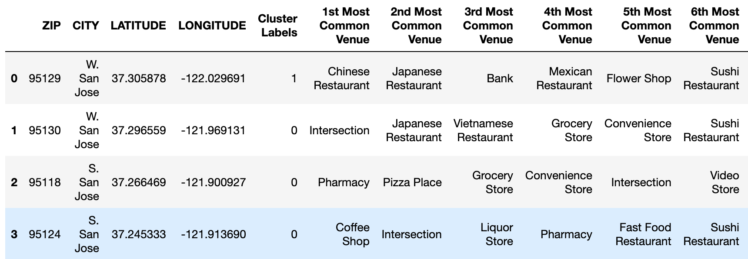

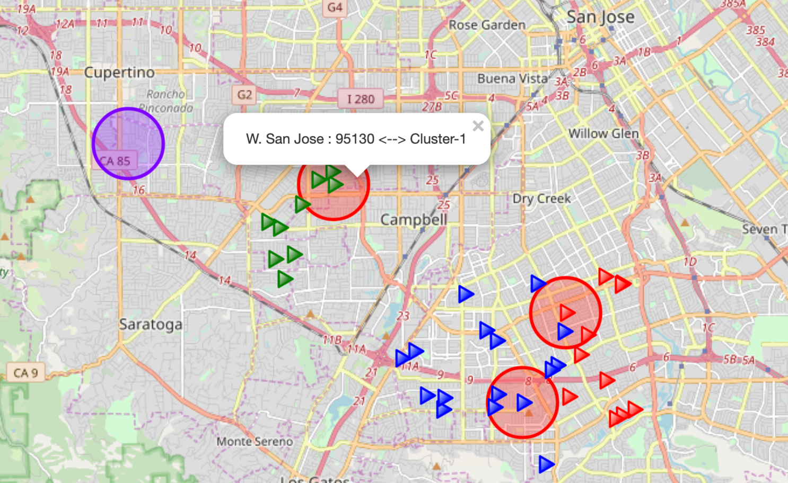

### 4.9 House Selection

The visualization maps and data analysis above will enable my clients to explore more options for his dream home hunting journey.

After examining all the alternatives, my client decides to buy a house at 95124 zip code area. Following is the summary ratings of each zip code:

|  |  |  |  |  |  |  |  |
| --- | --- | --- | --- | --- | --- | --- | --- |
| **Zip Code** | **Price** | **Crime Rate** | **School Rank** | **Park** | **Library** | **Railroad** | **Venues Favors** |
| **95129** | 1.9M | Low | 9.7 | Good | Good | Good | Good |
| **95130** | 1.7M | Low | 9.8 | Good | Good | Good | Good |
| **95118** | 1.4M | Low | 7.6 | Good | Good | Good | Fair |
| **95124** | 1.5M | Low | 9.1 | Good | Good | Good | Good |

So, what should my client do next? He can either go to hire a Real Estate broker or surfing homes for sale websites as below links:

* <https://www.zillow.com/>

* <http://julianalee.com/real-estate/#homes-for-sale>

## 5.0 Discussion Section

The visualization maps and data analysis in section 3 and 4 will enable my clients to explore more options on his dream home hunting journey. I know it is hard and somehow frustrated when decide to buy a house especially in the Silicon Valley. However, if you have no time and not really know what exactly you should be looking for, then this capstone project might help.

By the way, I encounter the mod_security issue when I used BeautifulSoup webscraping tools. Well, the real estate website hosting company is blocking some kind of requests to their servers (where your site is located). The whole mod_security Apache module is disabled for my site. There are no other ways around it and I have to manually handle some house sales data.

The Zillow API is quite useful. However, the most recent sales information may not be accessed via API. I can understand that Zillow may want to protect their valuable data. But, I may not use that API again if someone provide me more open one.

The kclusters (number of clusters) selection is tricky when using KMeans for the clustering analysis. The search radius (default is 500m) is also essential if you don't have a rough idea about the city. Sometimes, the result looks weird so you have to be patient and trying different combinations.

The Foursquare API has a limit of 950 Regular API Calls per day and 50 Premium API Calls per day for Sandbox Tier Accounts.

In general, I am quite impressed with the overall organization, content and lab works presented during the Coursera IBM Certification Course. I feel this Capstone project presented me a great opportunity to practice and apply the Data Science tools and methodologies learned. I will present the result of my study to my client. Of course, I would like to see this can help him to find his dream home in the coming months.

## 6.0 Conclusion Section

This project has shown me a practical application to resolve a real situation that gives me the intention to use Data Science tools.

The Folium is a powerful tool for data visualization which makes the analysis and decision making a lot easier. The FourSquare API is by all means a super tool to obtain all kinds of data based on the location. The ZillowAPI is good as long as you are not accessing to their protected data. The BeautifulSoup is terrific since webscraping is somehow exciting and it helps you to find your own treasure. I enjoy using all those tools.